**Create Picklist Fields On Enquiry Object**

Create picklist fields on enquiry object

1. Click on the gear icon and then select Setup.
2. Click on the object manager tab just beside the home tab.
3. After the above steps, Select enquiry Object

Now Select Fields and relationships from setup menu of the enquiry object.

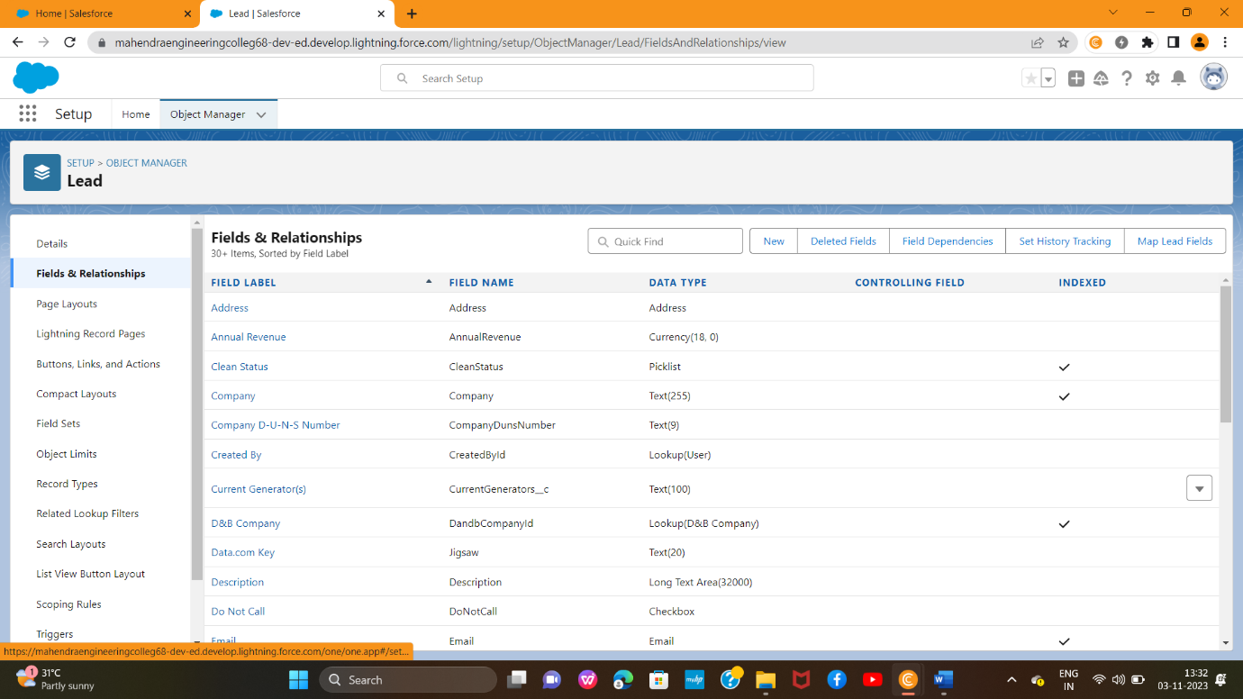

1. Click new and select Picklist fields ????next and enter label name(State) and select enter values option((Maharashtra, Gujarat, Rajasthan),next and Save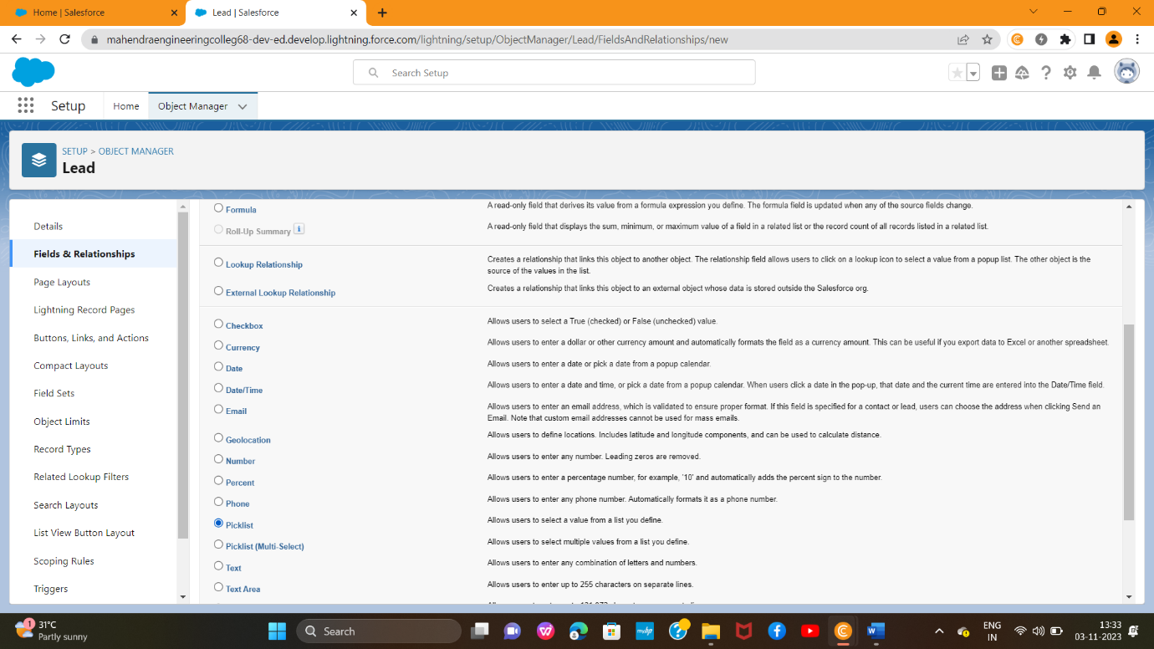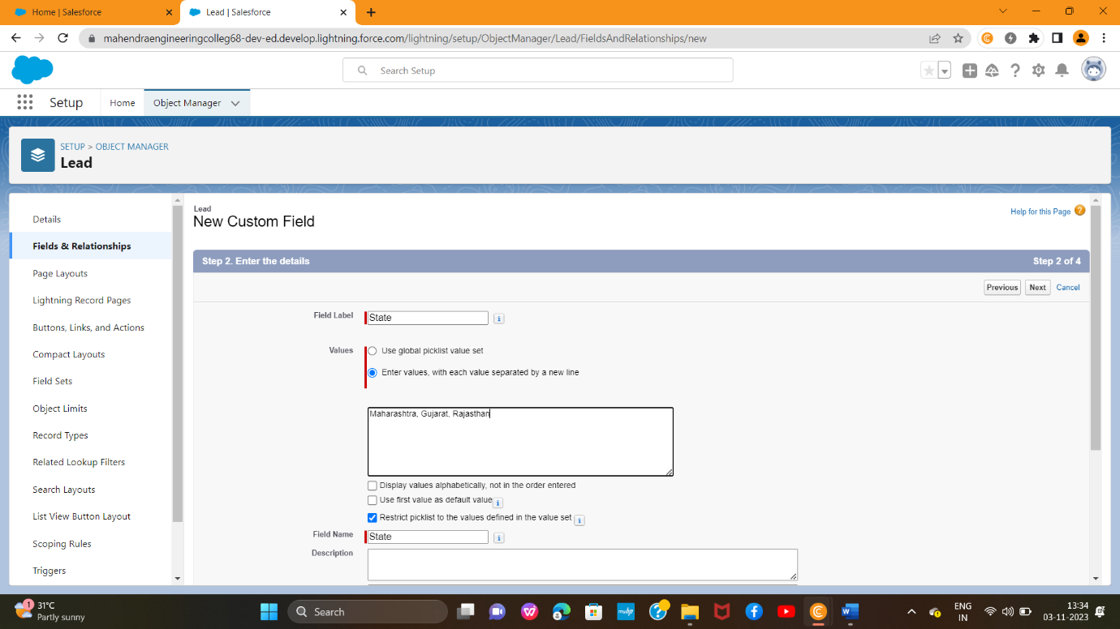
2. Note: we create picklist fields for city follow the above steps just change the Labels and values.

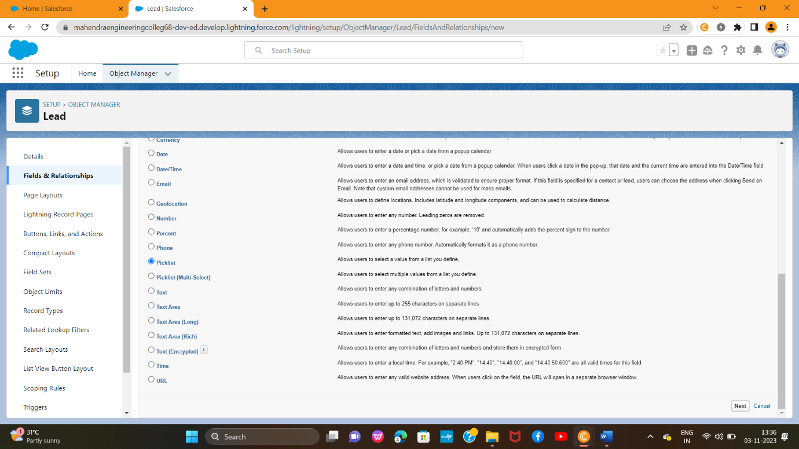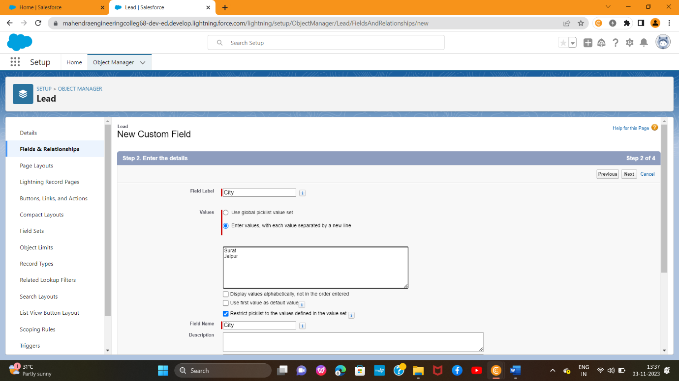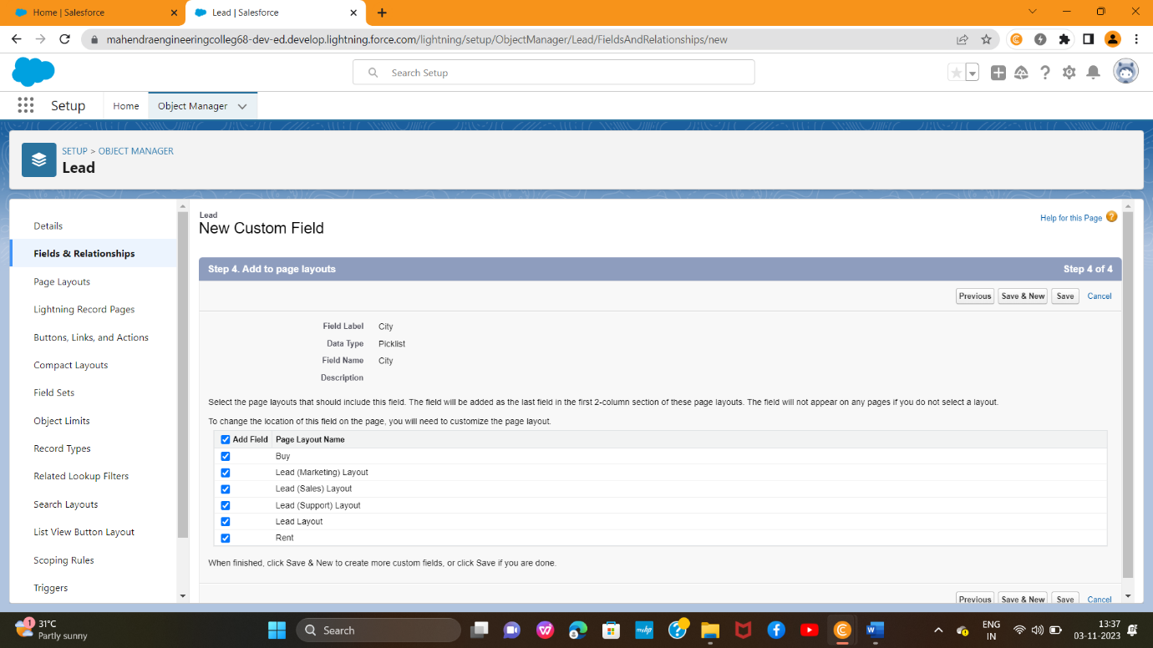

Create Field Dependency(on enquiry objects)

1. Create a dependency between these two picklists, so that when a state is selected, only respective Values are available.
2. The below steps will assist you in creating Field Dependencies.
3. Click on the gear icon and then select Setup.
4. Click on the object manager tab just beside the home tab.
5. After the above steps, Select enquiry Object
6. Now Select Fields and relationships from setup menu of the enquiry object.
7. Click Field Dependencies.
8. Click New.
9. Select State as the Controlling Field and select City as the Dependent Field.
10. Click Continue.
11. Select the appropriate Value in each column by double-clicking them.
12. Maharashtra:i) Nashik
13. Click Include Values. And it is also same for Gujarat & Rajasthan with its city.
14. Click Preview, then test the dependency by selecting different State and viewing the associate Values available for Particular state.
15. Click Close to close the preview window.
16. Click Save.

